**Economic Cost of Care in AKI patients 1 year post-discharge**

**Introduction**

**1.1 What is AKI?**

Acute Kidney Injury (AKI) is a clinical syndrome where patients’ kidneys are not functioning properly. Symptoms present on a clinical spectrum with varying degrees of pathology and subsequent symptom sequelae. If left untreated AKI may progress to chronic kidney disease (CKD), patients may require long term renal replacement therapy (RRT) in the form of dialysis or transplantation. The post-discharge care for these patients has many important implications for morbidity/mortality and of course long-term economic feasibility for the NHS.

This study should aid in the analysis of the best practice for follow up care in patients discharged into the community with a recent hospital admission of AKI. Additionally, this study aims to correlate healthcare events with data derived from national tariffs (Public Health Scotland PHS) to estimate the costs of key subgroups and provide analysis between them. In doing so, management pathways can be made more specific for the demands of the demographic enabling safer, more efficient, and patient-centred care. It is uncertain how fully optimised post-discharge care should look however it will need to be cost effective based on one of the strategies above.

**1.2 Causes**

There are a variety of causes for AKI which are typically divided into 3 categories: **pre-renal** (hypoperfusion to the nephrons), **intrinsic** (physical damage to the kidneys) and **post-renal** (obstructive causes) (1). Table 1 below details a list of the various causes.

|  |  |  |
| --- | --- | --- |
| **Pre-Renal** | **Renal** | **Post-Renal** |
| Hypovolaemia (sepsis, diarrhoea etc) | Glomerular Disease | Bulky obstruction |
| Vascular obstruction/stenosis | Renovascular disease/Vasculitis | Urinary retention |
| Decreased cardiac output | Tubulointerstitial disease | hypercalcaemia |

**Table 1: Causes of AKI**

**1.3 Epidemiology**

Further complicating matters, each healthcare practice may conform to its own coding regimen for counting cases of AKI leading to ambiguity of prevalence of disease. According to the UK Renal Registry Data published in 2017, it is estimated that there are roughly 650’000 cases of AKI annually (6). Researchers in Aberdeen recorded an incidence of AKI in up to 14% of all hospitalized patients (7).

**1.4 Diagnosis and Classification**

According to the BMJ, derived from KDIGO (Kidney Disease Improving Global Outcomes) guidelines, AKI should be suspected upon a rise in creatinine levels or an acute fall in urine output below 0.5mL/kg/hour. Should obtaining these values prove difficult, the clinical context should be considered. Figure 3 can be found in the appendix section and outlines the stage-based management of AKI.

Currently, Acute Kidney Injury Network (AKIN) classification is used to grade the severity of disease in AKI patients. AKIN 3 is more severe than AKIN 1 and as such, the financial burden too, becomes inflated due to cost of increasing ‘healthcare events’ post discharge.

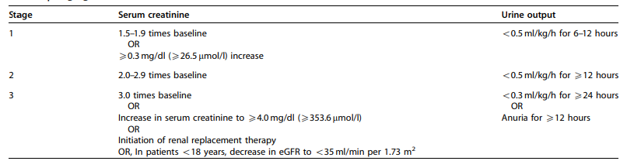

**Table 2: Staging of AKI (9)** from the Kidney Disease Improving Global Outcomes (KDIGO) detailing the staging process of AKI based on SCr and urine output

**1.5 Attaining cost-effectiveness**

Given the limited resources available, optimal distribution of care is paramount to prevent disease progression which is associated with increased mortality and morbidity, further illustrated by increasing ITU attendances and length of stay (LOS) in hospital for example. Researchers have found that could AKI be optimised it would save on excess hospital beds which could not only decrease the financial burden on the NHS but also allow for resource redistribution and given the current global health crisis, prevention is always better than a cure. Data published by NCEPOD (National Confidential Enquiry into Patient Outcome and Death) found that 1/3rd of inpatient AKI episodes were preventable (16). Understanding the costs involved with current practice would allow for comparison between economic impact of theoretical management pathways – a potential future prospect of this study.

**2. Method**

**2.1 Current literature**

Kerr et al. in a 2014 study reported that AKI was present in 2.43% of the 5.9 million admissions during 2010-11. These researchers found prevalence of the disease was much more common in those aged 80+ (5.74%) vs those in the 18-39 age bracket (17). Furthermore, when using another dataset with a population older than the first, the incidence of AKI was also reportedly higher. These researchers found that approximately 60% of all inpatient deaths had AKI. The LOS correlated with increased severity of AKI disease as did the average time spent on critical care. Unfortunately, these researchers were unable to fully analyse post-discharge care details as their dataset was lacking some of this information. My elective aims to fill this gap in the literature.

**2.2 Accessing Patient Data and Selection Criteria**

The data used for the analysis was collected from Grampian Data Safe Haven (DaSH) reflecting patients in the Grampian Health Board, who, on their last admission to hospital, were diagnosed with at least one episode of AKI. Approximately 39’000 patients were analysed from 2011-2019.. The estimated total healthcare usage during this time was collated for each patient. The target population in our study must have had a biochemical diagnosis recorded enabling AKI severity (based on SCr levels) to be integrated into the results. Data was restricted to adult-only patients (>18 years old).

Retrieval was completed following rigorous patient confidentiality protocols and only the necessary information was taken from these records. Although there are numerous psuedodata available, this project demanded careful consideration regarding which health-data and events would accurately answer our specific research question. Due to confidentiality restrictions only the most relevant data will be presented in this study. Certain variables from the DaSH dataset were unreliable and as such could not be included in this report without diminishing its integrity. For more on the data cleaning process see ‘Reflection’.

**2.3 Data analysis**

Our target population were divided into subgroups based on clinically relevant characteristics. The relevant healthcare usage (costs) was counted, summarised and systematically analysed for each subgroup using programming language R.

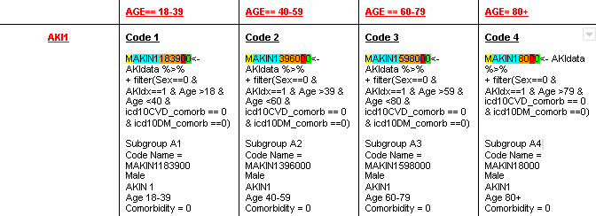

**Figure 1**: Code used to count costs/summarise information across subgroup A1-A4.

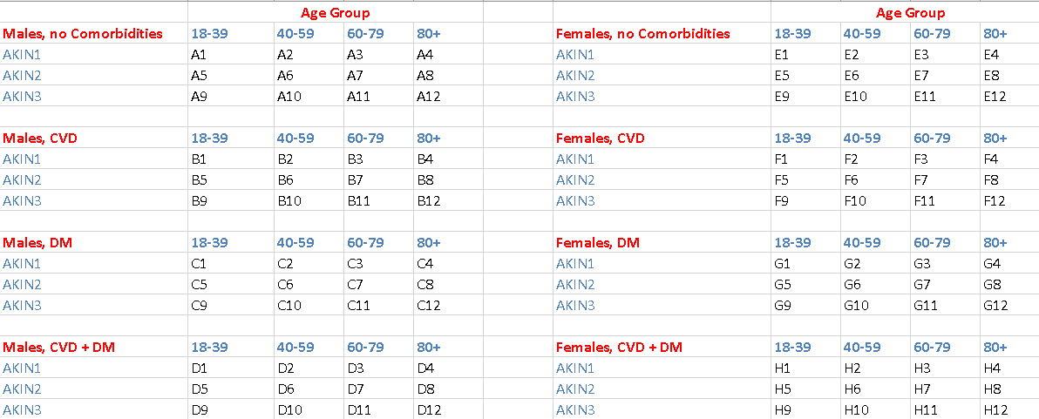

**Figure 2**: Subgroup allocations based on selected characteristics. Each letter represents a different co-morbidity combination or gender. Numbers represent the age band of the group or changing AKIN stage

***Health Costs***

|  |  |
| --- | --- |
| Outpatient clinic appointments | Renal outpatient clinic appointments |
| Emergency department attendances | HDU attendances |
| Length of hospital stay | Ambulance Usage |
| ITU attendances | Outpatient Blood Results |
| Date of RRT usage |  |

**Table 4: Healthcare** events (costs) counted for each subgroup for a total of 365 days post-discharge.

***Baseline Characteristics***

|  |  |
| --- | --- |
| **Sex (Male or Female)** | **Age** |
| Male | 18-39 |
| 40-59 |
| Female | 60-79 |
| 80+ |
| **Pre-existing conditions** | **AKI severity** |
| Diabetes (Y/N) | AKIN 1 |
| Heart Failure (Y/N) | AKIN 2 |
|  | AKIN 3 |

**Table 6**: Baseline characteristics used to determine subgroup allocation

Subgroups which were smaller than others (fewer than 5 individuals) have been anonymised for protection of patient details. An example calculation can be seen below for subgroup A1. This process was then repeated for the remaining ninety six subgroups.

From the literature it was evident that certain health events were more likely to occur at certain times from discharge than others. For better understanding of this effect health costs were arranged into 3 fixed time segments.

|  |
| --- |
| **Time from discharge** |
| 0-31 days |
| 32-90 days |
| 91 – 365 days |

**Table 5:** Fixed time segments used for data analysis

**2.5 Cost Matching**

Publicly available unit costs on the PHS and NHS website allowed for cost matching of a variety of healthcare events including unit costs for ambulance usage, RRT treatment and outpatient clinic costs per attendance for a variety of specialties. Additionally, the Personal Social Services Research Unit (PSSRU) website was used to provide costs for taking bloods in an outpatient setting (200).

Outpatient blood results

Typically a patient would have their bloods taken by a practice nurse and then the results would be interpreted by the clinician. For this reason the cost of outpatient blood results per patient was taken as an average of the cost of clinician time per attendance and that of a nurses’ time. This data was available via the PSSRU website.

Renal replacement therapy

RRT unit cost was calculated by taking the average unit cost for peritoneal dialysis and haemodialysis. The data from the NHS website was split into patients 19 years and above for each type of dialysis a patient could receive.

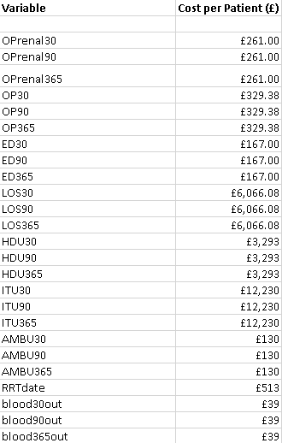

**Figure 3**: Details of costs of each variable

**Results**

**Males**

**Figure 4:** Total Cost of each of all subgroups in the Male category

Figure 4 above shows **Males with DM + CVD** when totalled across all subgroups have the combined highest cost of £1.1 million per year per patient (pypp).

**Figure 5**: Average cost of each subgroup in Male category

When looking at averages across the categories, this trend pervades. The average cost of males with CVD (£52’479) is less than the average cost of the subgroups present in the Males: No comorbidity category.

**Figure 6**: Subgroup analysis of total cost for male categories

On closer inspection of these groups we find that **males with** **CVD** (C ) have less post-discharge costs than **males with diabetes mellitus** (B). Male patients with both CVD and DM (D) seen an increase of ~137% (£300k per annum) compared to group A (Males: No Comorbidities).

**Females**

**Figure 7**: Total Cost of each of all subgroups in the Female category

The two most expensive groups in the female category were subgroup F and H, representing **Females with Diabetes Mellitus** (£1.2m) and **Females with diabetes mellitus** **and CVD** (£800k) respectively.

**Figure 8**: Average cost of each subgroup in Female category

From Figure 8 above we can see average post-discharge care per group (averaged across all subgroups within larger group) is largest in female patients with DM. The lowest averaged group was Females with CVD.

**Figure 9**: Subgroup analysis of total cost for male categories

The most expensive groups of patients lie in the Females: CVD + DM and Females: DM categories.

**Population of Groups/Subgroups**

**Figure 10**: Population of each group

Females without CVD/DM (E) and Males without CVD/DM (A) were the most densely populated groups.

**Figure 11**: Population of each subgroup

Figure 11 above shows that as we increase in age band, the number of patients in the subgroup largely increases up until 80+ category in which it curtails.

**Male category**

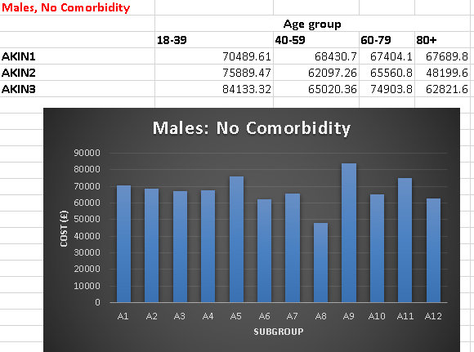

**Figure 12**: Subgroup analysis comparing the most (Males: CVD +DM) and least (Male: No comorbidity) expensive male groups.

Of all groups in the male category, Males: CVD + DM costed the most. An average price of approximately £93k per year per patient (pypp) regardless of age or AKIN stage. The highest costing subgroup was D10 ( Male: CVD + DM, Age: 40-59; AKIN3). The average price across all males was £73k. When compared to no co-morbidities (group A), with an average of approximately £68k pypp, we can see the impact of dual comorbidity on price.

**Female category**

**Figure 13**: Subgroup analysis comparing the most (Females: DM) and least (Females: CVD) expensive female groups.

Above we see that the most expensive subgroups from the female category were F9 (DM, AKIN 3, 18-39 years old), followed closely by F1 (AKIN1, DM, 18-39) then H10 and H3. This trend is one mimicked by the male data. Overall female patients AKIN3, aged 18-39 and with a diagnosis of DM were the most expensive post-dischage. On average, the highest subgroup cost pypp difference was between females with DM and Females with CVD approximating £41k.

**Discussion**

Given that we have an ageing population and patients with AKI are typically older with greater comorbidities and thus typically require more interventions than younger patients (26) one would assume subgroups containing patients 80+ years old would be the most expensive. However, this does not align with the results. In both male and female categories the greatest cost was from D10 (Male: CVD & DM, 40-59, AKIN3) and F9 (Female: DM, AKIN 3, 18-39). This is possibly due to older patients not qualifying for more expensive interventions and so although they may have more incidence of later stage AKIN disease, they are not accumulating most costs across particular groups of patients. Additionally on inspection of Figure 11 it is clear that patients in 80+ subgroups are relatively less populated than other subgroups. The majority of patients tend to lie in a central distribution.

The greatest number of patients can be found in AKIN stage 1 (1-4). However, these patients, when collated and totalled still do not appear as one of the most expensive groups. A possible answer for this would be that AKIN1 is associated with more numerous smaller costs. This would explain why although AKIN stage 3 is not the most populated group, they still account for the great post-discharge care costs pypp. AKIN1 is treated largely in the community whereas AKIN3 is more likely to be associated with hospitalisation and need for critical care (26). The average cost of inpatient care compared to that of an outpatient clinic can be visualised in Figure 3 above. Additionally, patients in later stage AKI disease are also more likely to have a greater number of healthcare events per person and thus removing any bias that an increased population size (AKIN1) would have.

Design Considerations

**Specialty-specific tariffs**

The calculated costs per attendance for outpatient clinics was calculated as a weighted average across only relevant specialties. The specialties the patients were likely to not visit (dermatology, child psychiatry for example) were removed and a new average for OP clinic cost per attendance was calculated.

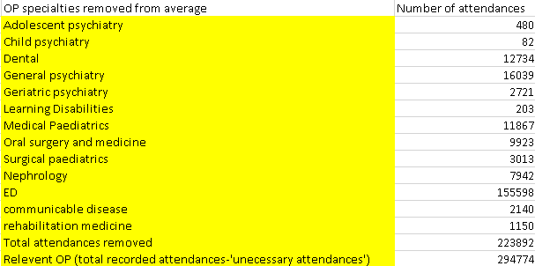

**Figure 3**: Example of ‘unnecessary’ OP specialties removed from total to provide more specific weighted average OP cost per attendance per patient.

**Potential Flaws**

AKI has a wide variety of presentations and symptom sequalae. Consequentially, there are several specialties involved in caring for these patients with a wider number of associated healthcare professionals, investigations and management plans (12). Furthermore, true incidence of AKI is obscured by improper use of identification tools (13). Over-dependence on laboratory results, incongruence between disease presentation and recognition and breakdowns in communication (poor handover) between secondary and primary care are all factors contributing (to varying degrees) to the potentially poor management of AKI patient’s post-discharge

This is a common issue when attempting to provide economic analysis as different health boards vary in their treatment protocols and pay-regimens for facilities and operator time (physicians). Each of these different ‘costs’ varies depending on the health board in which patients are in. For that reason, the study was restricted to the Grampian Health board for uniformity of cost analysis.

A possible flaw in this study is that it was assumed all OP clinics were taken by consultants however, a proportion of clinics, especially given the nature of long-term comorbidities, are taken by specialist nurses. Overall, this may lead to a less accurate depiction of economic demands of each subgroup.

If early post-discharge monitoring enables us to reduce a proportion of readmissions the question becomes whether it is cost effective to do so. This will depend on whether we can target people (subgroups), or must follow everyone, and whether we must send them to renal OP appointments or if it can be handled fully in the community.

**Conclusion**

**Cost to the NHS**

AKI occurs at all stages in the healthcare system. It is especially prevalent in patients on ICU wards; quick resolution of AKI has been found to improve mortality rates in ICU patients (14)(15).

Due to the ambiguity of the presentation of AKI and yet its seemingly increasing prevalence (possibly due to an aging population), the need has never been greater to further develop our understanding of the medicoeconomic demand these patients require

By ensuring guidelines are rigorous in identification of AKI, variability in clinical practice is reduced and costs are optimised with fewer patients progressing in the disease process. Possibly this work will guide further improvements in clinical pathways for patients. This economic approach to evaluating patient healthcare usage post-discharge may be adapted for another specialty or may be used to evaluate efficiency of current care.

**Potential Improvements**

1. Apply process to different disease processes
2. Apply process to different health boards
3. Investigate management of paediatric AKI
4. Better reporting of AKI
5. Primary care data – blood test monitoring is not sufficient
6. Modelling of future management pathways given certain ‘inputs’
   1. Strategy planning for a changing clinical landscape

**References**

1. - [Causes | Background information | Acute kidney injury | CKS | NICE](https://cks.nice.org.uk/topics/acute-kidney-injury/background-information/causes/)
2. [Diagnosis of AKI | Diagnosis | Acute kidney injury | CKS | NICE](https://cks.nice.org.uk/topics/acute-kidney-injury/diagnosis/diagnosis-of-aki/)
3. [Acute kidney injury - Symptoms, diagnosis and treatment | BMJ Best Practice](https://bestpractice.bmj.com/topics/en-gb/3000117)
4. Table 1 - <https://www.researchgate.net/figure/Cancer-causing-acute-kidney-injury-AKI-and-or-chronic-kidney-disease-CKD_fig1_317137577>
5. Figure 1 - [Urine Analysis: Part 16 – Urine potassium (K), Quantitative 24 urine or Random sample – Labpedia.net](https://www.labpedia.net/urine-analysis-part16-urine-potassium-k-quantitative-24-urine-or-random-sample/)
6. [Reporting-the-rate-of-AKI-January-2018.pdf (thinkkidneys.nhs.uk)](https://www.thinkkidneys.nhs.uk/aki/wp-content/uploads/sites/2/2018/03/Reporting-the-rate-of-AKI-January-2018.pdf)
7. [Intermediate and Long-term Outcomes of Survivors of Acute Kidney Injury Episodes: A Large Population-Based Cohort Study - American Journal of Kidney Diseases (ajkd.org)](https://www.ajkd.org/article/S0272-6386(16)30256-6/fulltext)
8. National Institute for Health and Care Excellence. Early Identification and Management of Chronic Kidney Disease in Adults in Primary and Secondary Care. National Institute for Health and Care Excellence: London, UK. Guideline 182. 2014.
9. [KI_SuppCover_2.1.indd (kdigo.org)](https://kdigo.org/wp-content/uploads/2016/10/KDIGO-2012-AKI-Guideline-English.pdf)
10. Bsdf
11. Lassnigg A, Schmidlin D, Mouhieddine M, et al. Minimal changes of serum creatinine predict prognosis in patients after cardiothoracic surgery: a prospective cohort study. J Am Soc Nephrol 2004; 15: 1597–1605.
12. [(PDF) Incidence and Outcomes in Acute Kidney Injury: A Comprehensive Population-Based Study (researchgate.net)](https://www.researchgate.net/publication/6492146_Incidence_and_Outcomes_in_Acute_Kidney_Injury_A_Comprehensive_Population-Based_Study)
13. Hackworth LA, Wen X, Clermont G, et al. Hospital versus community acquired acute kidney injury in the critically ill: differences in epidemiology (abstr). J Am Soc Nephrol 2009; 20: 115A.
14. Hoste EA, Clermont G, Kersten A, et al. RIFLE criteria for acute kidney injury are associated with hospital mortality in critically ill patients: a cohort analysis. Crit Care 2006; 10: R73.
15. Levy MM, Macias WL, Vincent JL, et al. Early changes in organ function predict eventual survival in severe sepsis. Crit Care Med 2005; 33: 2194–2201.
16. Stewart, J. National Confidential Enquiry into Patient Outcome and Death Adding insult to injury: a review of the care of patients who died in hospital with a primary diagnosis of acute kidney injury (acute renal failure): a report of the National Confidential Enquiry into Patient Outcome and Death (2009), 2009London National Confidential Enquiry into Patient Outcome and Death pg. 98
17. [economic impact of acute kidney injury in England | Nephrology Dialysis Transplantation | Oxford Academic (oup.com)](https://academic.oup.com/ndt/article/29/7/1362/1844079)

(55) [RIFLE and AKIN classifications for acute kidney injury: a critical and comprehensive review | Clinical Kidney Journal | Oxford Academic (oup.com)](https://academic.oup.com/ckj/article/6/1/8/468698)

(26) - https://www.ncbi.nlm.nih.gov/pmc/articles/PMC5176133/

200 - https://www.pssru.ac.uk/project-pages/unit-costs/unit-costs-2020/

201 - https://www.england.nhs.uk/national-cost-collection/#ncc1819

**Appendix**

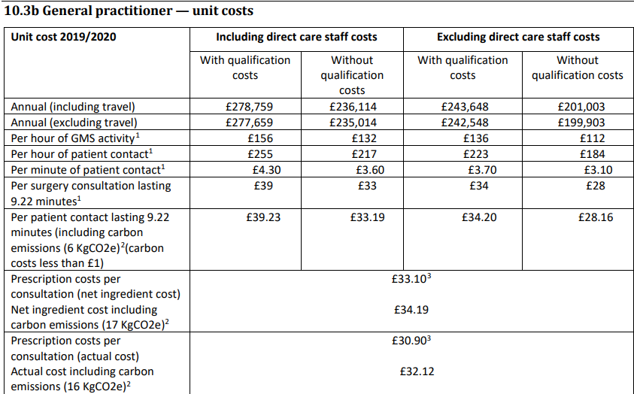

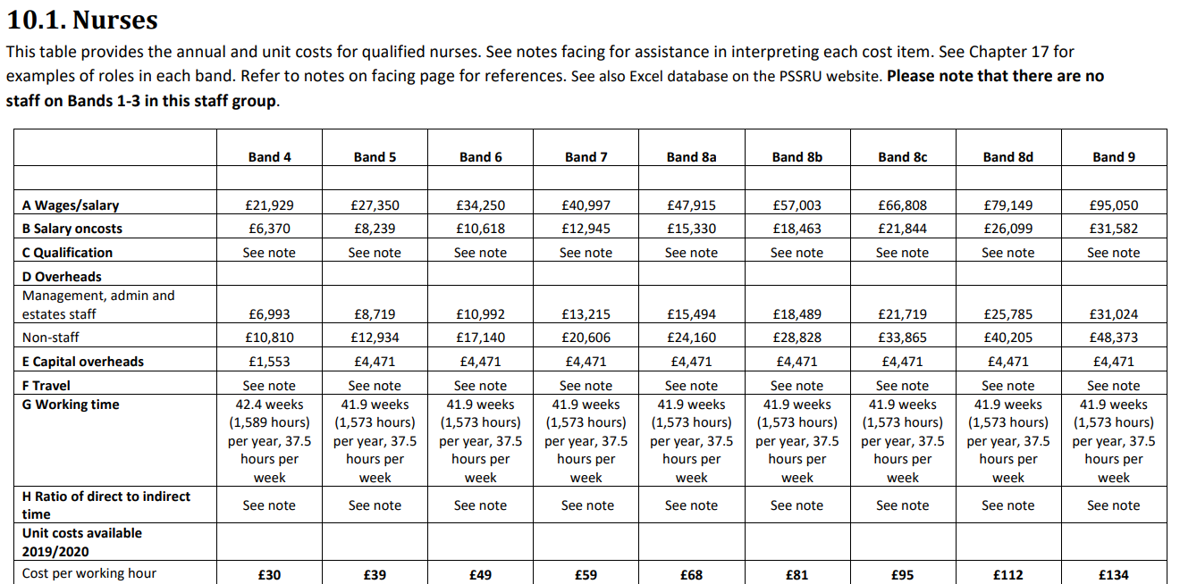



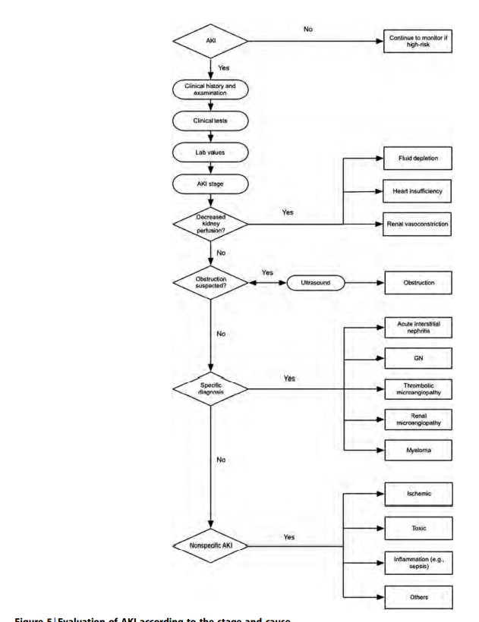

**Figure 3 - evaluation of AKI according to stage and cause**

***Comments for improvement***

1. Add in fact that AKI alone is independent cause of increased mortality and morbidity.
2. 30% of cases were avoidable - a study by the NCEPOD
3. AKI is underrecorded in patient notes - put this into the discussion section of the thesis.

By 51550827

Word Count: (<2500)